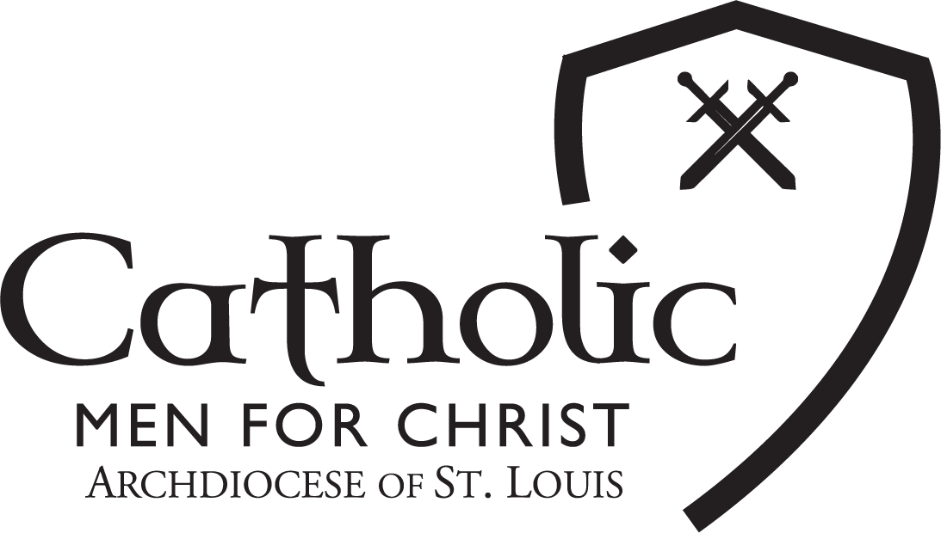

Catholic Men for Christ Conference Sponsorship Options 2023
Please return this form with your selection and payment to Tammy Chumley – evangelization@archstl.org
Our mission is help build and strengthen the Kingdom of God in the Archdiocese of St. Louis and beyond by engaging, ,education, and encouraging all Catholic men to live their faith and to lead their families in accordance with the orthodox teachings of the Catholic Church. Catholic Men for Christ are men of faith, men of action, catalysts for good and warriors against evil. Every dollar raised helps us continue this mission year after year. Thank you for promoting your business or organization by becoming a Champion Supporter or advertising in our program.
Become a Champion Supporter
PLATINUM
$5,000
(2 available)
GOLD
$2,500
SILVER
$1,000
BRONZE
$500
Complimentary Tickets | 8 | 6 | 4 | 2
Logo Online
Logo Screen Time During Event
Advertisement in Program | Full  Page | Half  Page | Quarter Page | Listed as sponsors
Podium Recognition
Social Media Promotion
Logo on E-Blasts
Dedicated Post-Conference
Email
5 Minute Podium Time
Promo Video shown during conference
Free Vendor Table in Best Location

Advertise in the Program - JPG or PNG
PLACEMENT | DIMENSIONS (WIDTH X HEIGHT) | RATE
Back Cover Full Page (Color) | 4.5 in. width x 7.5 in. length | $650.00
Inside Front or Back Cover Full Page (Color) | 4.5 in. width x 7.5 in. length | $500.00
Full-Page Package (Black & White) | 4.5 in. width x 7.5 in. length | $400.00
Half-Page Package (Black & White) | 4.5 in. width x 3.75 in. length | $200.00
Quarter-Page Package (Black and White) | 4.5 in. width x 2 in. length | $100.00
Program Listing of Name |  | $50.00

Questions? Please call Tammy Chumley at 314.792.7182 or email evangelization@archstl.org
_ _ _ _ _ _ _ _ _ _ _ _ _ _ _ _ _ _ _ _ _ _ _ _ _ _ _ _ _ _ _ _ _ _ _ _ _ _ _ _ _ _ _ _ _ _ _ _ _ _ _ _ _ _ _ _ _ _ _ _ _ _
BUSINESS OR ORGANIZATION: _________________________________________________________________
CONTACT NAME: ___________________________________________________________________________
ADDRESS: _________________________________________________________________________________
CITY: _______________________________________________ STATE: __________ ZIP: __________________
EMAIL ADDRESS: ____________________________________________________________________________
PHONE: ____________________________________________
Champion Supporter Options: PLATINUM GOLD SILVER BRONZE
Program Ad Size: _______________________ = $__________
CHAMPION SUPPORTER PACKAGE: $___________
PROGRAM ADVERTISEMENT: $___________
TOTAL: $___________
Champion Sponsors: please submit your business or organization logo/image to evangelization@archstl.org.
Make checks payable to “Catholic Men for Christ” and mail to:
Catholic Men for Christ
20 Archbishop May Dr.
St. Louis, MO 63119
We will contact you when your form and payment have been received to discuss details.
Thank you!

